Helping Verbs (Auxiliary Verbs)

🔹 What is Helping Verbs (Auxiliary Verbs)
# Source: AI Source: Provided by: [Data Path: Persons Table -> ID Column: 1, Name_En Column: Motasem Essam] -> From: [Chatgpt (GPT-4-turbo)] on [7/27/2025]
Helping verbs, also called auxiliary verbs, are verbs that are used with a main verb to form a verb phrase. They help express tense, mood, voice, possibility, necessity, or question form.

✅ Definition:
# Source: AI Source: Provided by: [Data Path: Persons Table -> ID Column: 1, Name_En Column: Motasem Essam] -> From: [Chatgpt (GPT-4-turbo)] on [7/27/2025]
A helping verb is a verb that comes before the main verb and helps it function grammatically, especially in forming tenses, negatives, questions, or passive voice.

🧩 Helping Verb + Main Verb = Verb Phrase
# Source: AI Source: Provided by: [Data Path: Persons Table -> ID Column: 1, Name_En Column: Motasem Essam] -> From: [Chatgpt (GPT-4-turbo)] on [7/27/2025]
📌 Example:
- She is running. → "is" (helping verb) + "running" (main verb)
- They have finished their work. → "have" (helping) + "finished" (main)

🛠️ Three Main Categories of Helping Verbs:
# Source: AI Source: Provided by: [Data Path: Persons Table -> ID Column: 1, Name_En Column: Motasem Essam] -> From: [Chatgpt (GPT-4-turbo)] on [7/27/2025]
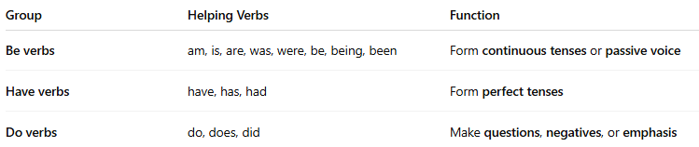
Group | Helping Verbs | Function
Be verbs | am, is, are, was, were, be, being, been | Form continuous tenses or passive voice
Have verbs | have, has, had | Form perfect tenses
Do verbs | do, does, did | Make questions, negatives, or emphasis

🌟 Modal Auxiliary Verbs (Special Helping Verbs)
# Source: AI Source: Provided by: [Data Path: Persons Table -> ID Column: 1, Name_En Column: Motasem Essam] -> From: [Chatgpt (GPT-4-turbo)] on [7/27/2025]
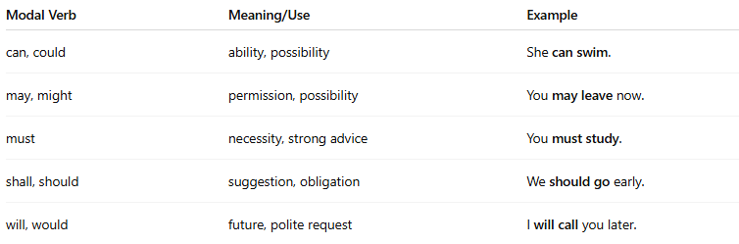
These add meaning like possibility, necessity, or ability:
Modal Verb | Meaning/Use | Example
can, could | ability, possibility | She can swim.
may, might | permission, possibility | You may leave now.
must | necessity, strong advice | You must study.
shall, should | suggestion, obligation | We should go early.
will, would | future, polite request | I will call you later.

📚 Examples of Helping Verbs in Sentences:
# Source: AI Source: Provided by: [Data Path: Persons Table -> ID Column: 1, Name_En Column: Motasem Essam] -> From: [Chatgpt (GPT-4-turbo)] on [7/27/2025]
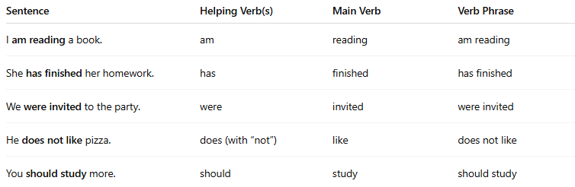
Sentence | Helping Verb(s) | Main Verb | Verb Phrase
I am reading a book. | am | reading | am reading
She has finished her homework. | has | finished | has finished
We were invited to the party. | were | invited | were invited
He does not like pizza. | does (with “not”) | like | does not like
You should study more. | should | study | should study

🧠 Why are Helping Verbs Important?
# Source: AI Source: Provided by: [Data Path: Persons Table -> ID Column: 1, Name_En Column: Motasem Essam] -> From: [Chatgpt (GPT-4-turbo)] on [7/27/2025]
They help express:
- Tense (She is eating, She was eating, She has eaten)
- Voice (The letter was written by John)
- Mood/Modality (He should go, You must stay)
- Negatives (They do not understand)
- Questions (Did you see it?)

✅ Summary Table:
# Source: AI Source: Provided by: [Data Path: Persons Table -> ID Column: 1, Name_En Column: Motasem Essam] -> From: [Chatgpt (GPT-4-turbo)] on [7/27/2025]
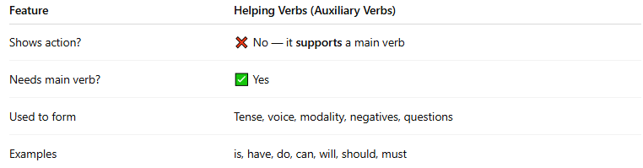
Feature | Helping Verbs (Auxiliary Verbs)
Shows action? | ❌ No — it supports a main verb
Needs main verb? | ✅ Yes
Used to form | Tense, voice, modality, negatives, questions
Examples | is, have, do, can, will, should, must

